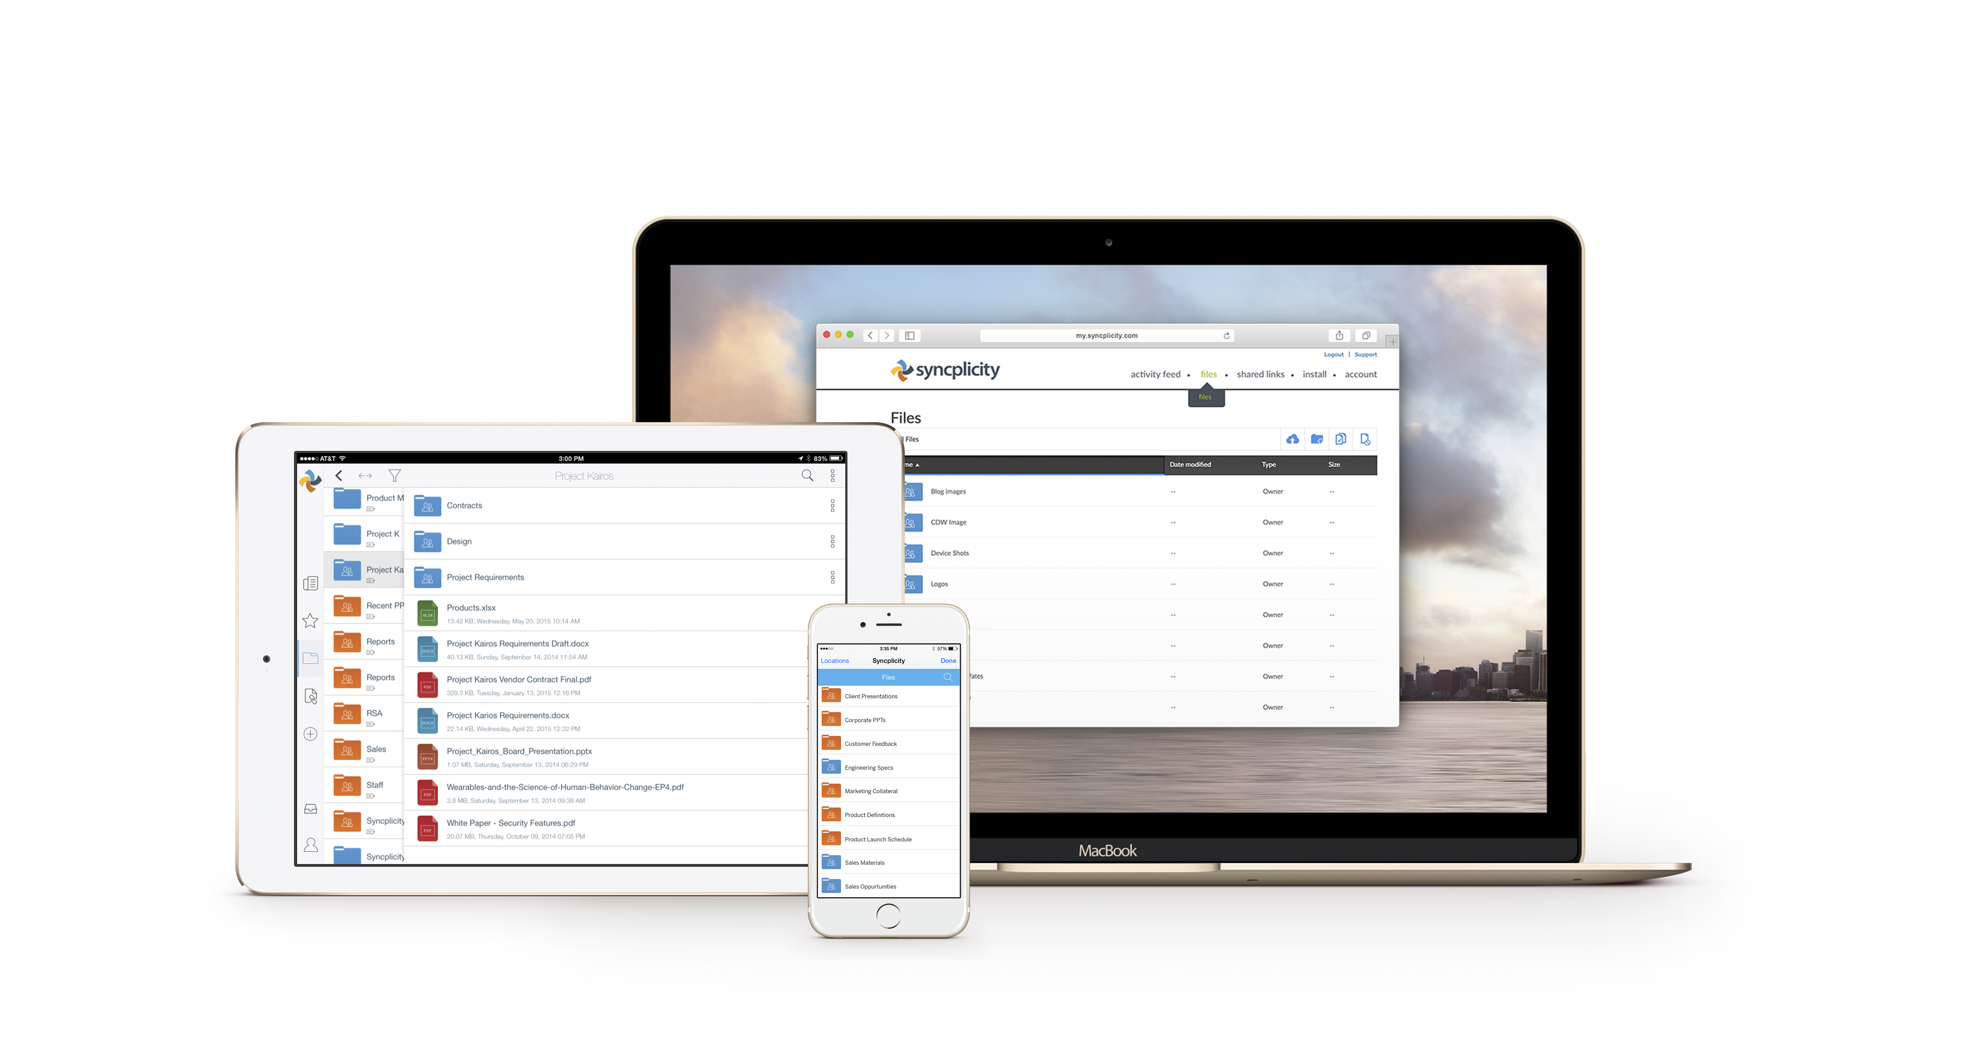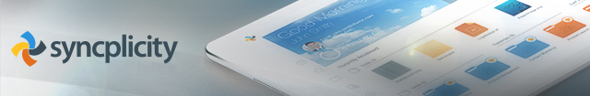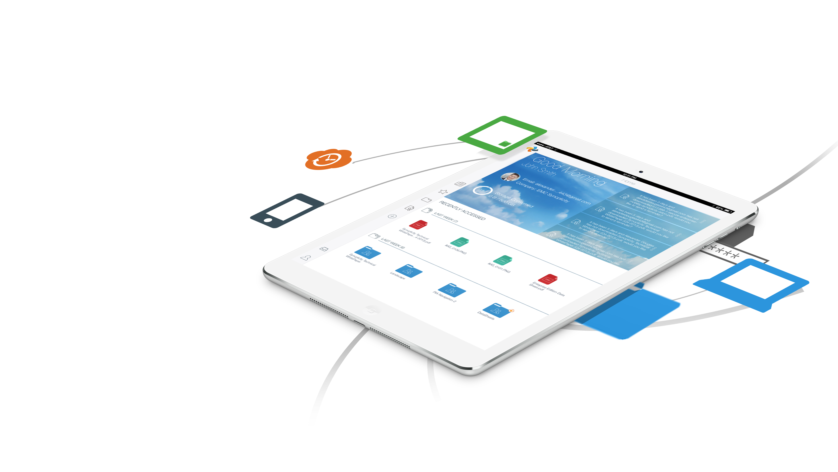­­­­­ ­

**Meet Syncplicity** - our elegant, powerful, new corporate cloud storage solution for global file sharing and document collaboration. Whether you’re editing or sharing a PowerPoint or collaborating on a Word doc, Syncplicity makes file syncing and sharing a breeze.

Sync, Share, Secure   
Access any file, anytime, anywhere, from any device

Getting started is simple  
Syncplicity is already installed on your computer and being backed-up in the secure cloud.   
To learn more and get started, check out the short online training videos at [URL]

Hit the road  
To download and install a Syncplicity mobile app, simply click one of the links below.   
Windows | iOS | Android

We think Syncplicity is going to bring all sorts of new freedom, productivity, and creativity to our collaborative work, and we hope you love using   
it as much as we do!

Sincerely,

[name(s)]

Syncplicity is as mobile as you are!  
With Syncplicity, you’ll be able to sync, backup, and easily share any folder or file. You won’t need to copy files. You’ll have no file-size restrictions, and Syncplicity is as mobile as you are. You’ll be able edit, sync, and share files anytime, anywhere, from your tablet or smartphone!